UNIONBANK 125CE 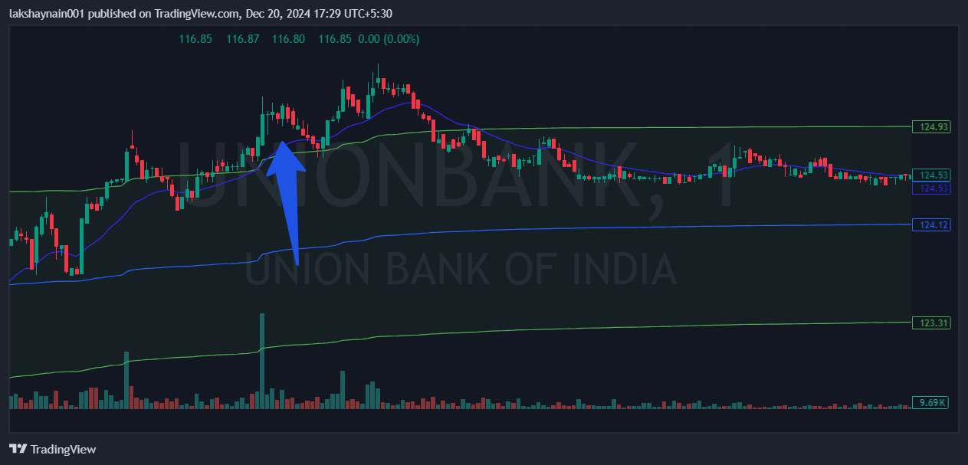
- Broke day high
- Trading above vwap
- Trading with 20EMA support

