Atul nov 8000CE
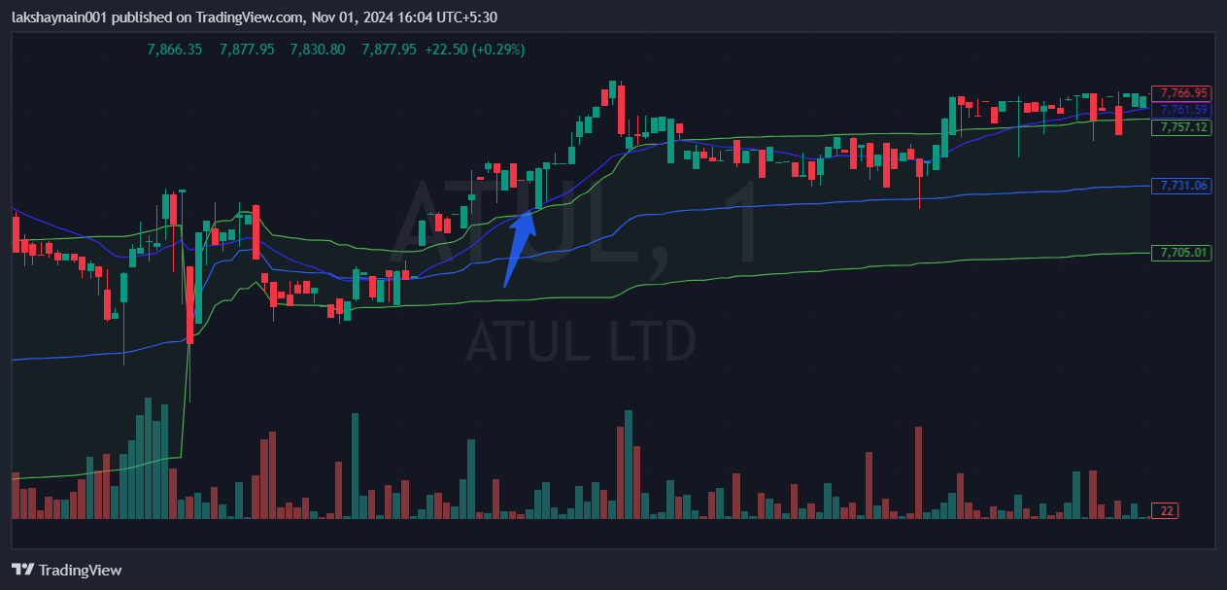
- Trading above 20EMA and breaks day high
- Trading above vwap
- Nifty auto on move

