HAL nov 4200CE
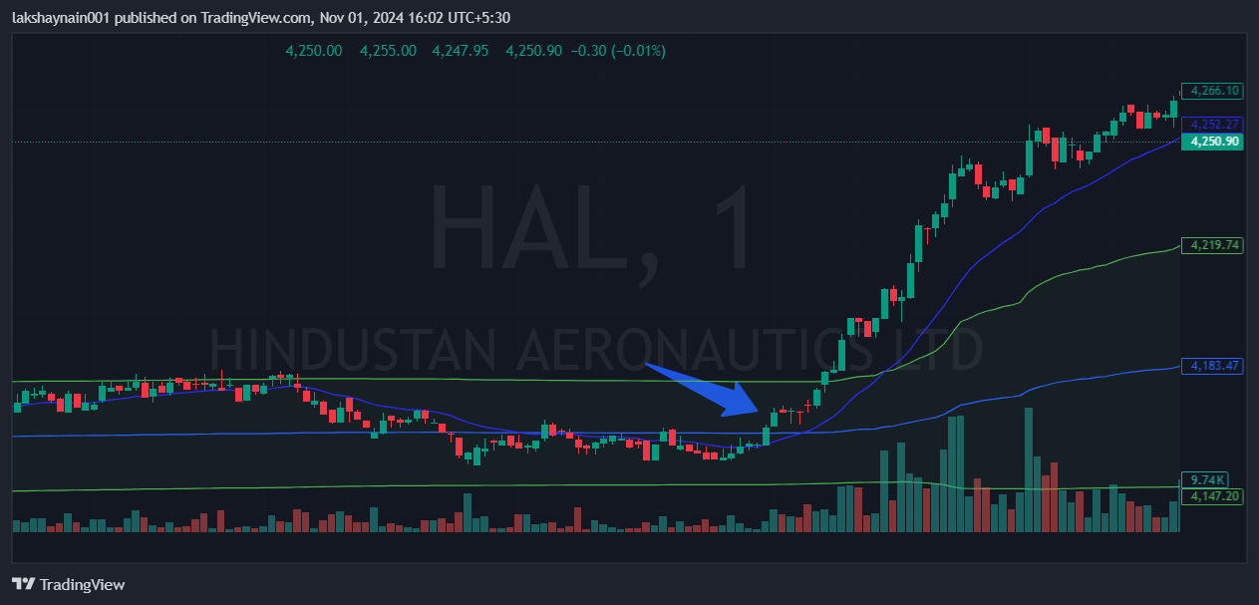
- Breaks day high
- Broke 20EMA resistance
- Trading above vwap

