Auropharma 1500CE
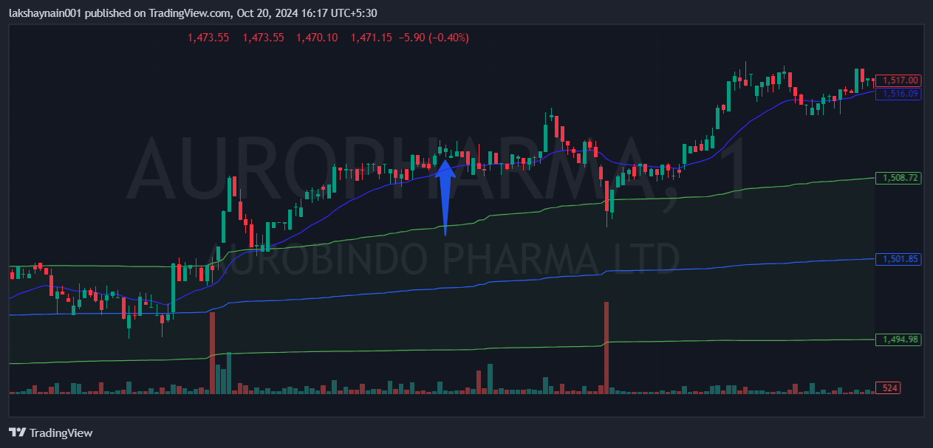
- Price breaks day high
- Trading with 20EMA support
- Exited earlier due to heavy selling at 13:22

