Muthootfin 1960CE
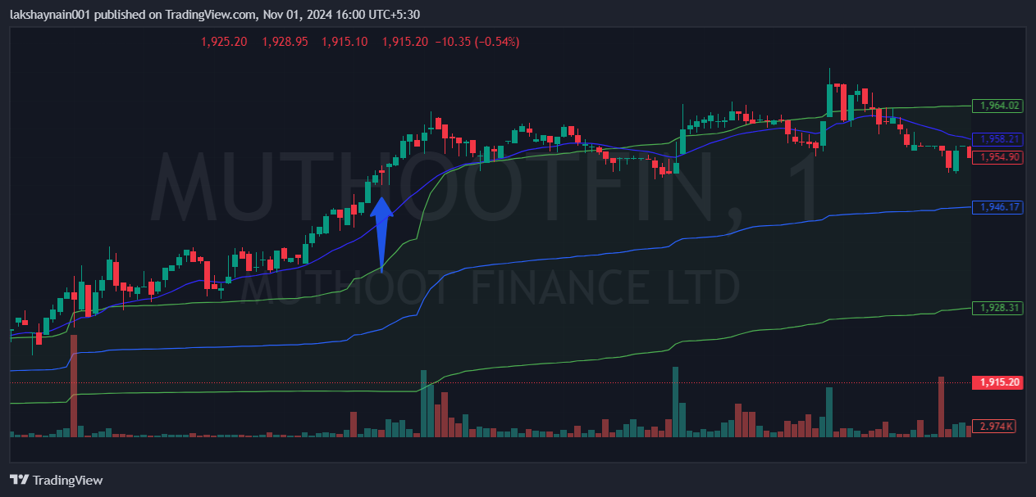
- Nifty financial on move
- Trading with strong 20EMA support
- Trading above vwap

