Auropharm 1400PE nov
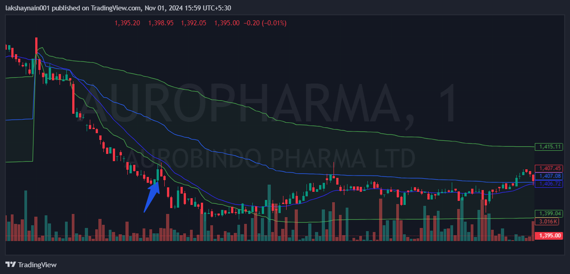
- Rejected from 20EMA ‘
- Trading below vwap
- Breaks previous day low

