Cipla nov 1500CE
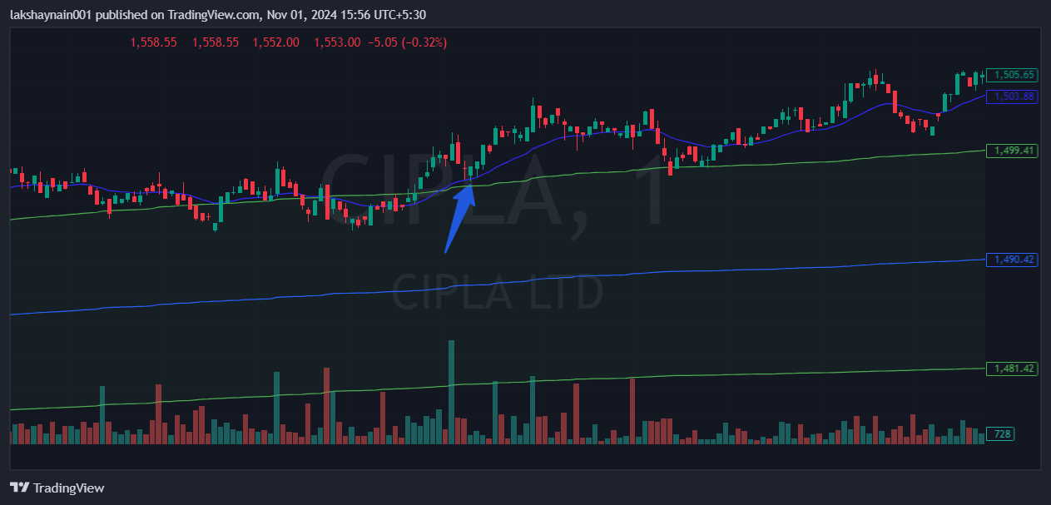
- Opened gap up in morning
- Trading wth 20EMA support
- Trading above vwap

