Polycab 6600 PE
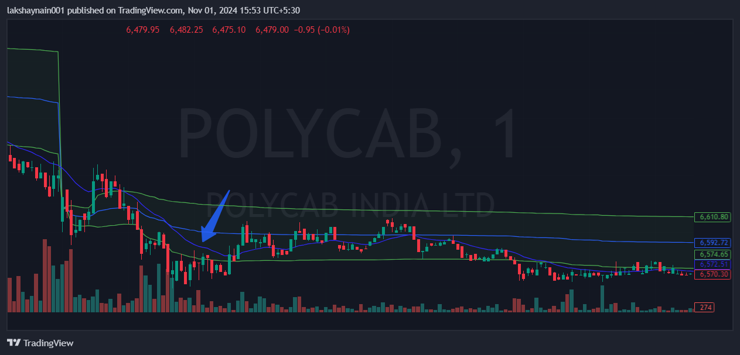
- Breaks previous day low
- Trading below vwap and 20MA
- SL hit above vwap

