Heromoto 5200CE

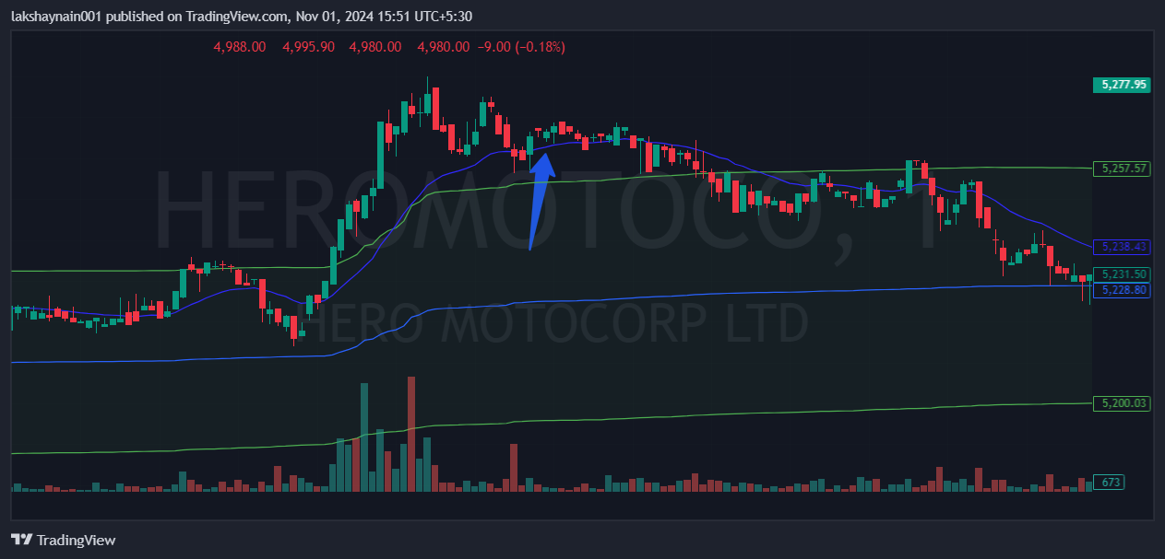
- Nifty auto on move
- Breaks day high at entry above 20EMA
- Trading above vwap

