Ongc 265PE
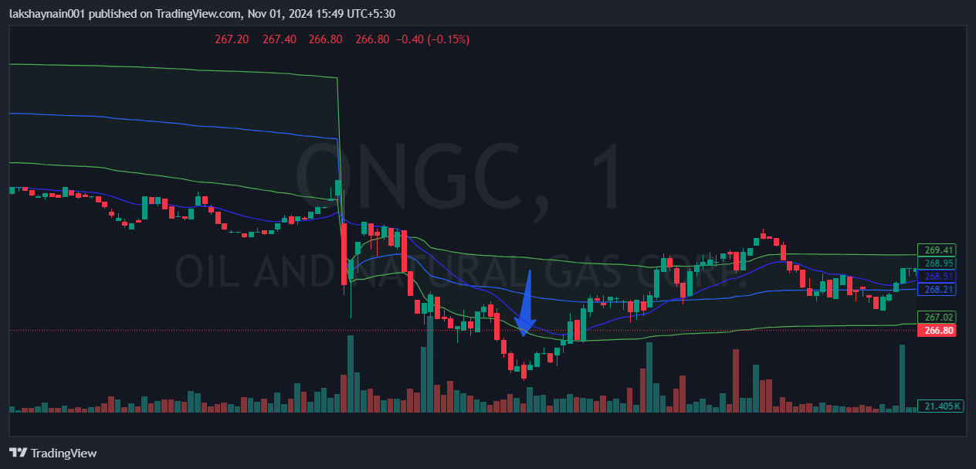
- Price rejected from 20EMA
- Trading below vwap
- SL hit above vwap

