Nestleind 2380CE
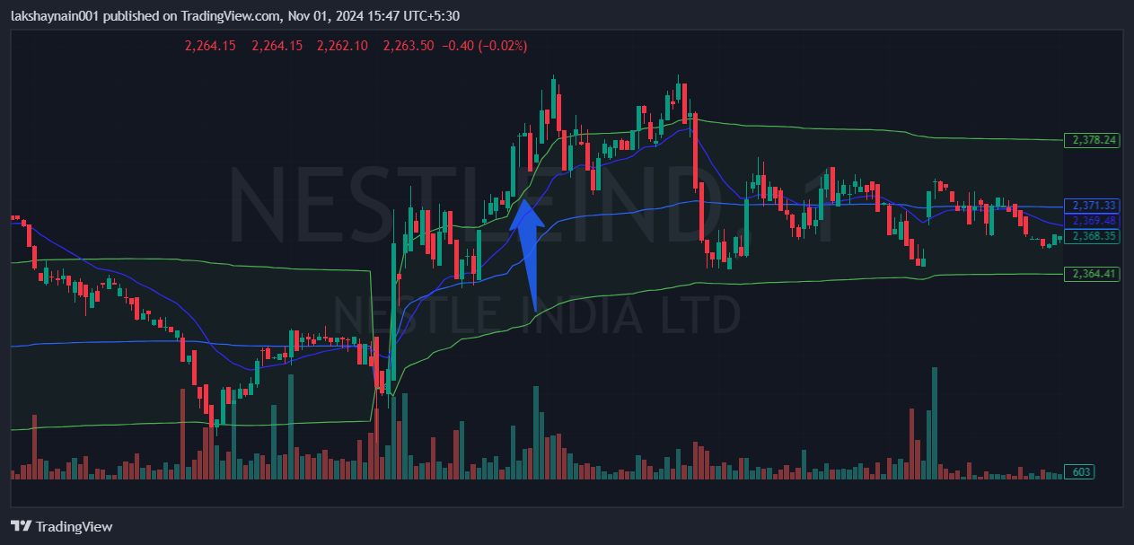
- Price bounced from 20EMA in morning
- Trading above vwap
- Breaks day high

