Maruti 12000CE
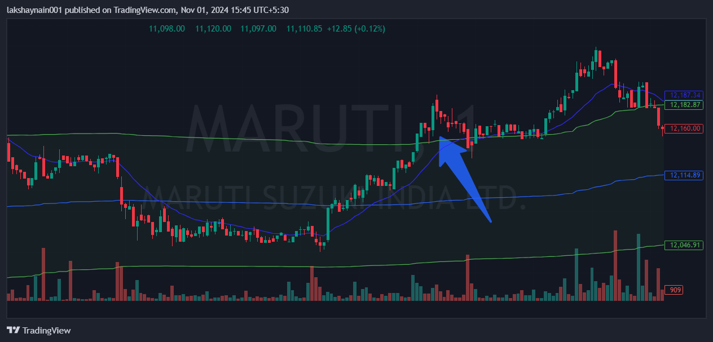
- Price opened gap up
- Nifty auto on move
- Trading above vwap and 20EMA support

