SUNPHARMA 1900CE
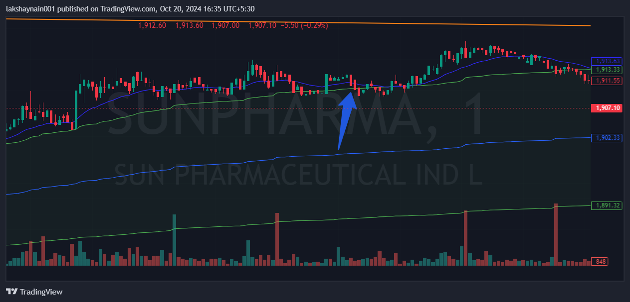
- Price opened gap up
- Breaks day high and got sideways
- Exited at CMP

