ICICIBANK 1250CE
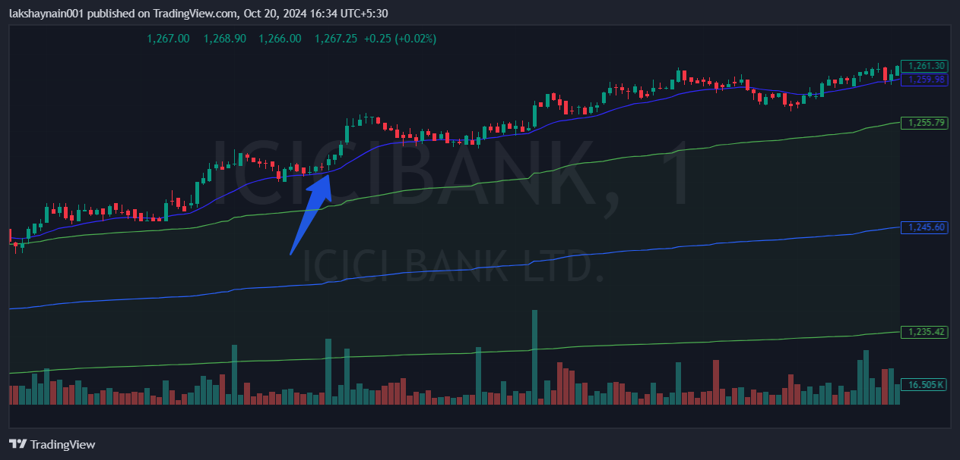
- Price trading with 20EMA support
- Banknifty on fire
- Trading above vwap

