BTST Petronet 355CE
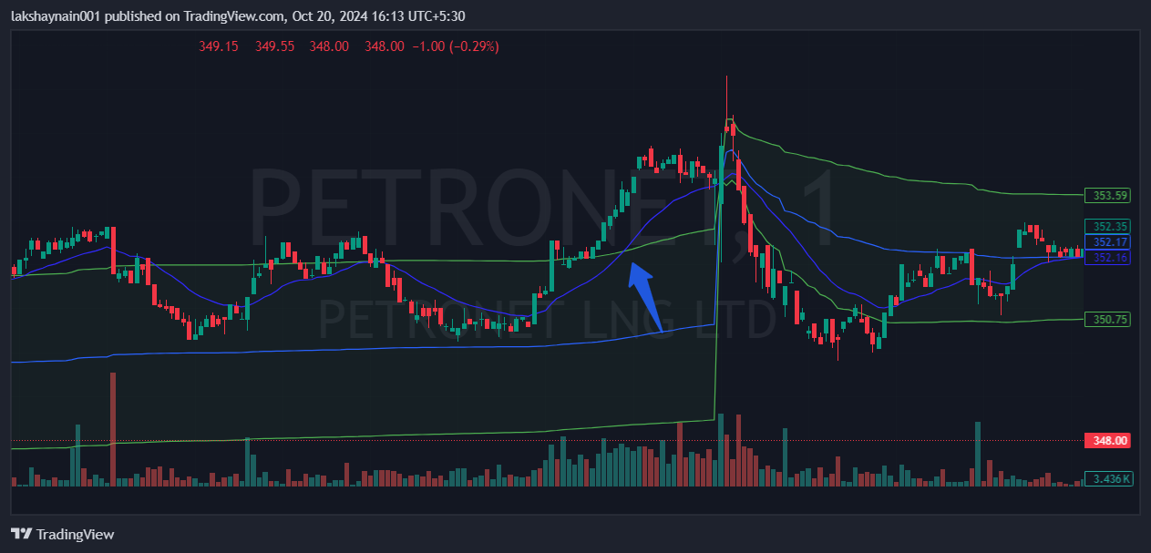
- Price breaks day high with volumes
- 20EMA crossed vwap upper band

