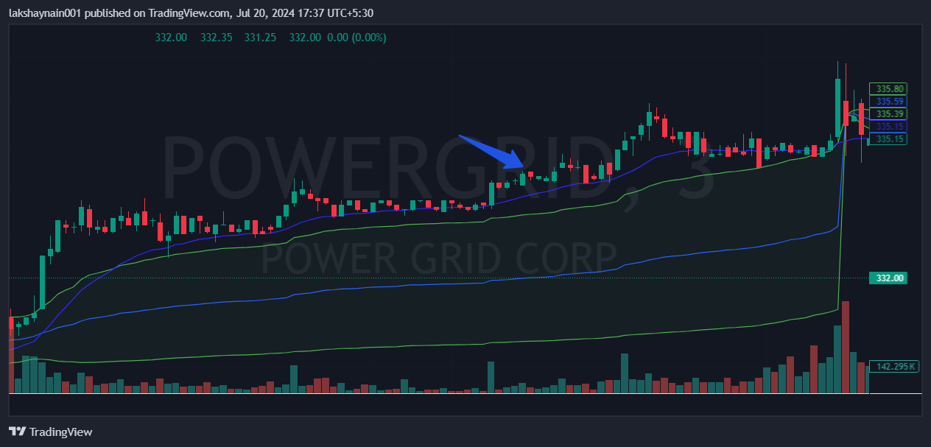
Powergrid 340CE
- Price at day high
- 20EMA support
- Above vwap trading for the day

