Persistent 5000PE
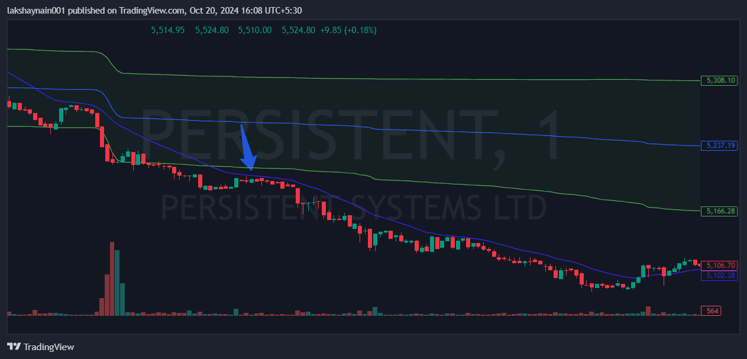
- Nifty IT down
- Breaks day low below vwap
- Rejected from 20EMA

