LT 3500CE
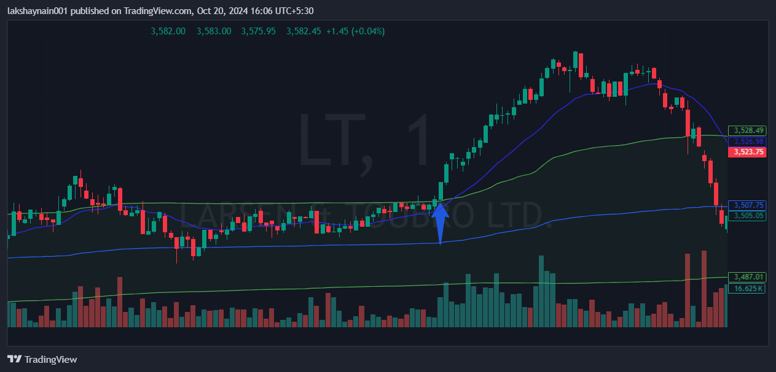
- Price opened gap up but rejected in morning
- Breaks day high
- 20EMA crossed vwap

