ABB 8300CE
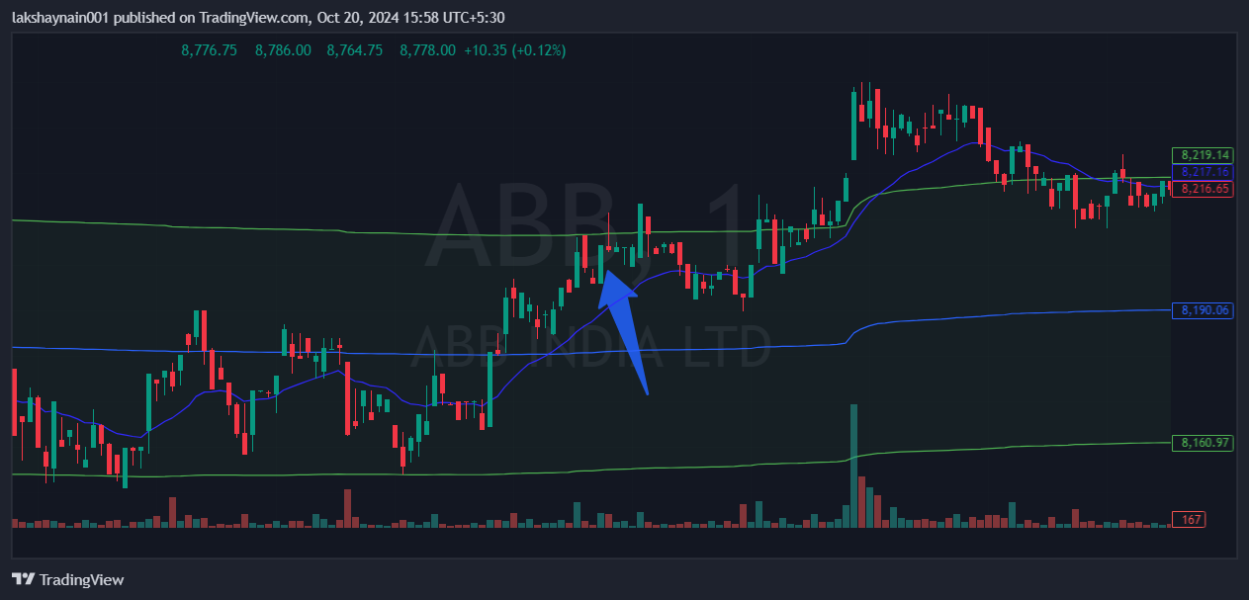
- Price opened gapup
- Crossover of 20EMA and vwap
- Breaks day high

