Lupin Nov 2100PE
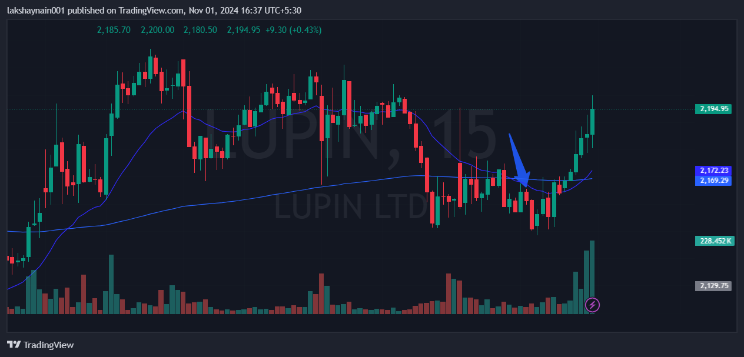
- Deathcrossover in 15min Tf
- Rejected from 20EMA
- Sl hit above 200EMA closing

