BEL nov 300CE
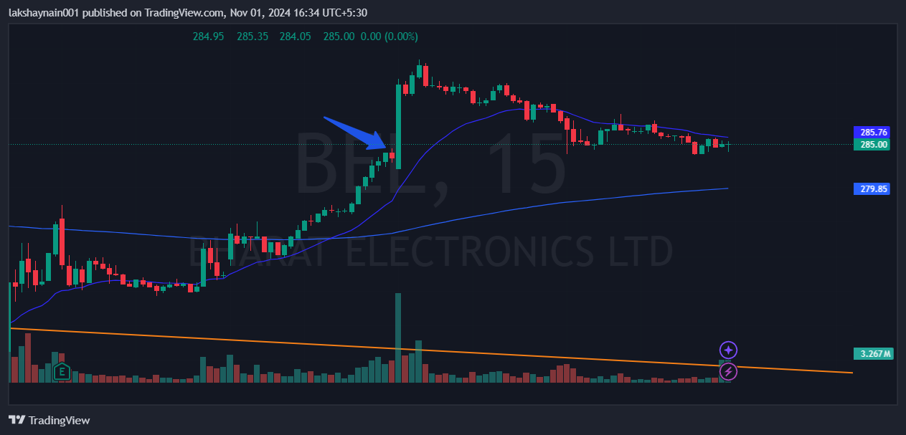
- Price breaks week’s high
- Trading above 20EMA
- Golden crossover

