HCLTECH 1900CE
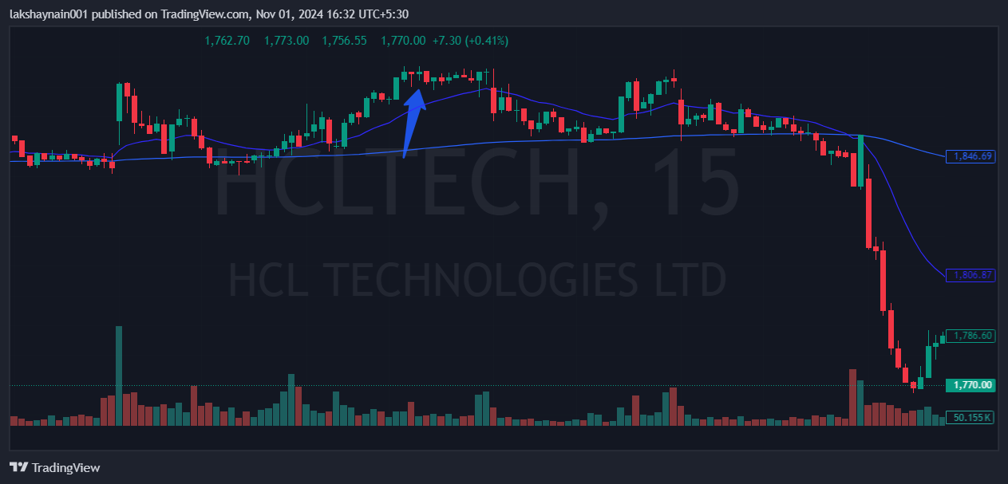
- Breaks week’s high
- Trading above 20EMA and 200EMA
- Sl hit with death crossover

