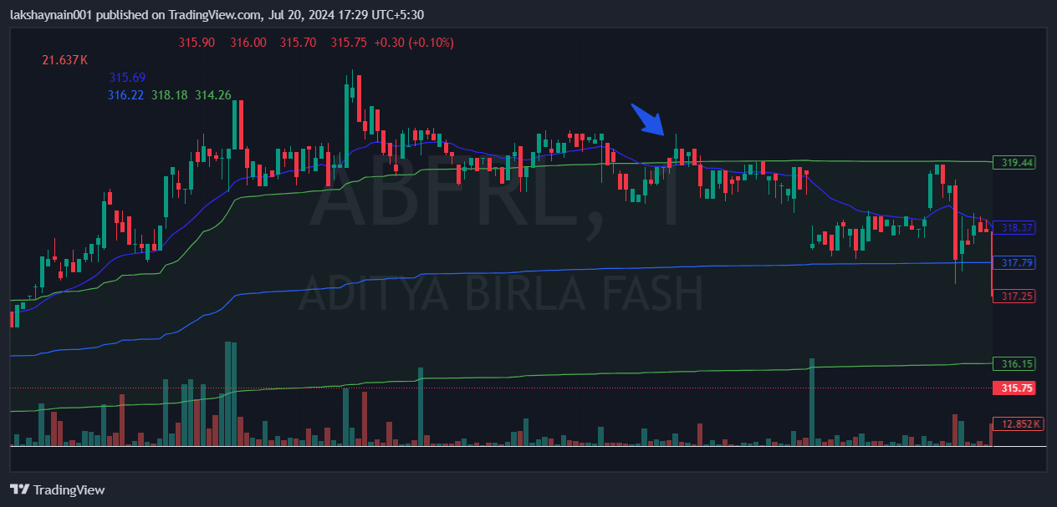
Abfrl325CE
- Price above vwap
- Price closed above 20EMA
- Earlier price opened gapup in morning

