Bhartiairtl 1660PE Nov
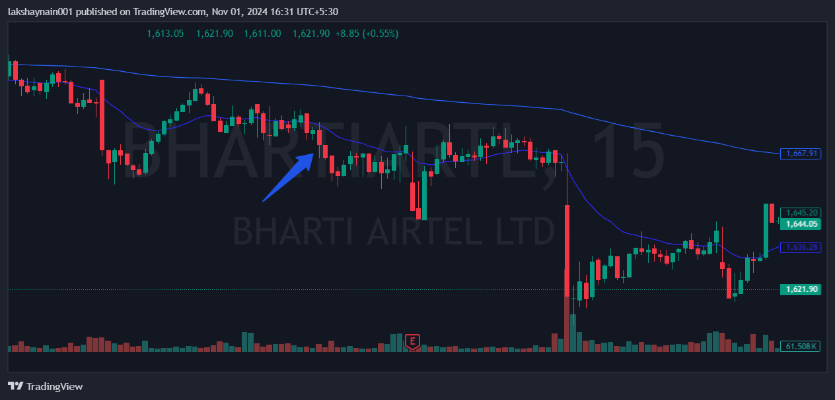
- Break previous day low
- Rejected from 20EMA
- Breaks previous swing low

