HEROZERO ONGC 270PE
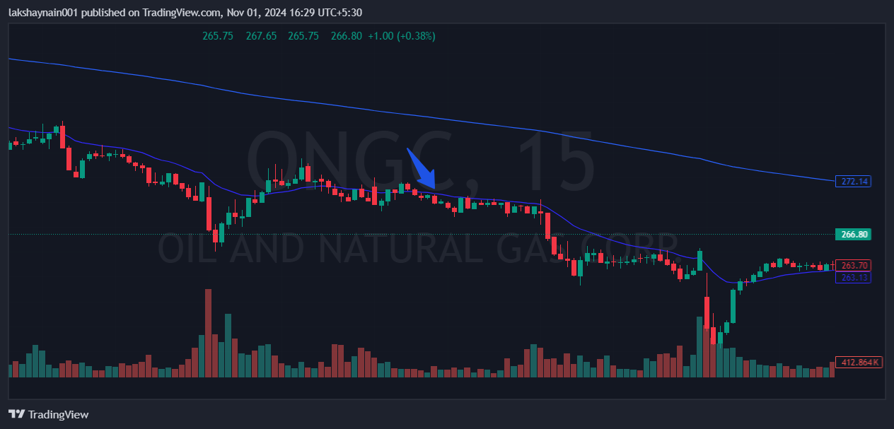
- Stock in downtrend from last one week
- Rejected from 20EMA
- Nifty energy down

