DLF 870CE
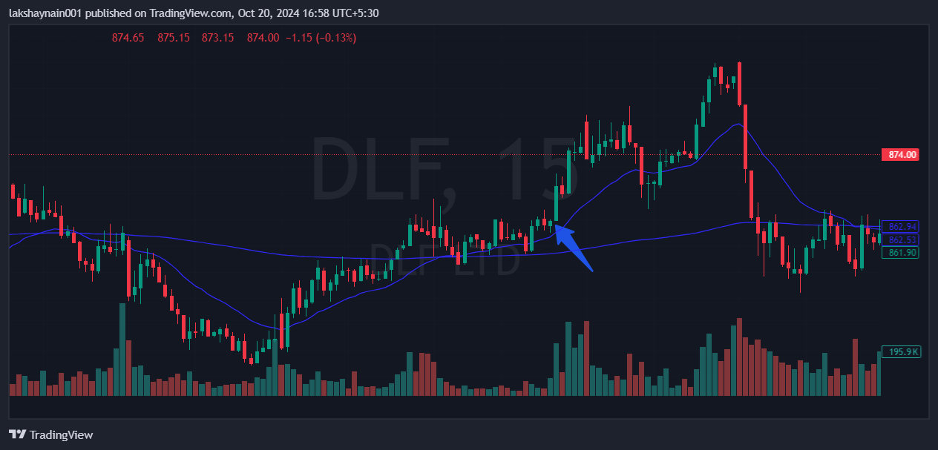
- Price sustained 20EMA
- Breaks previous two day high
- Got thrust from200EMA earlier

