GODREJPROP 3050CE
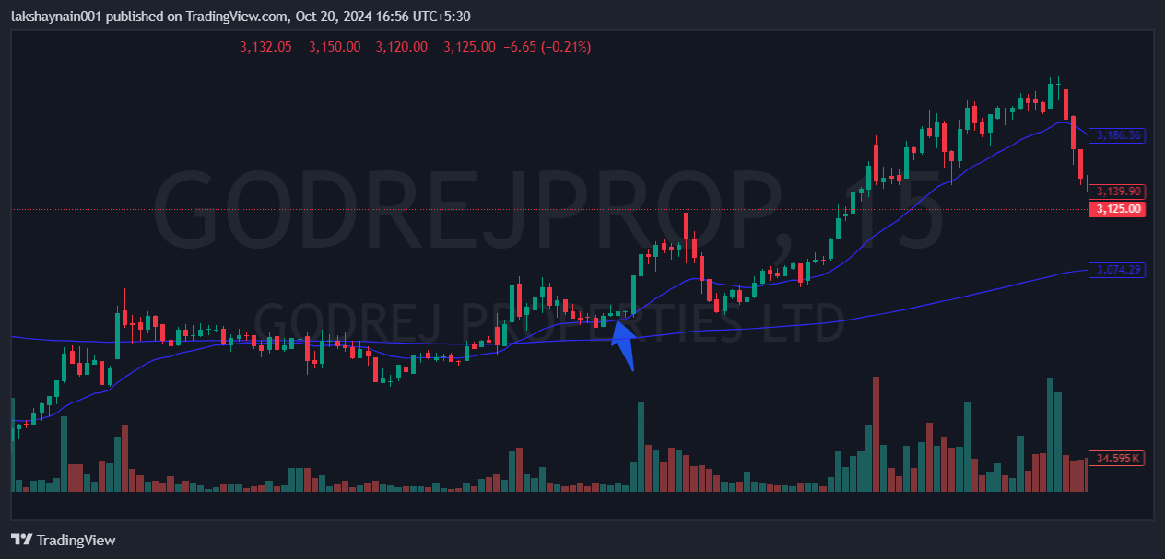
- Golden crossover previous day
- Price sustained 20EMA
- Trading above 200EMA also

