Unitdsp 1500PE
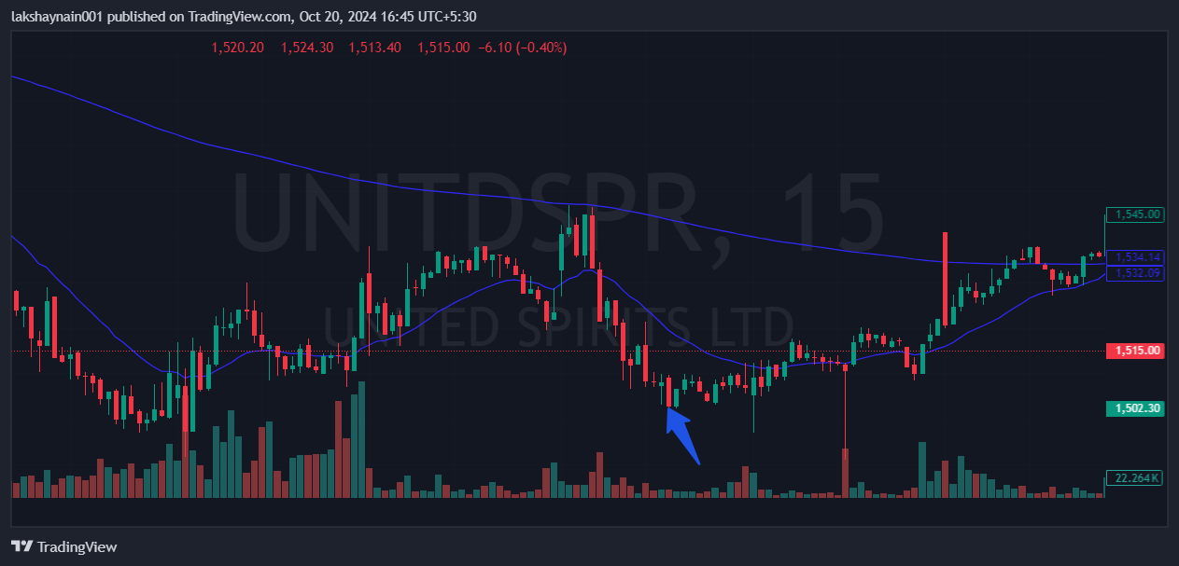
- Breaks previous three day’s low
- Got rejected from 200EMA
- Trading below 20EMA
- Sl hit above 20EMA

