LTIM 6400CE
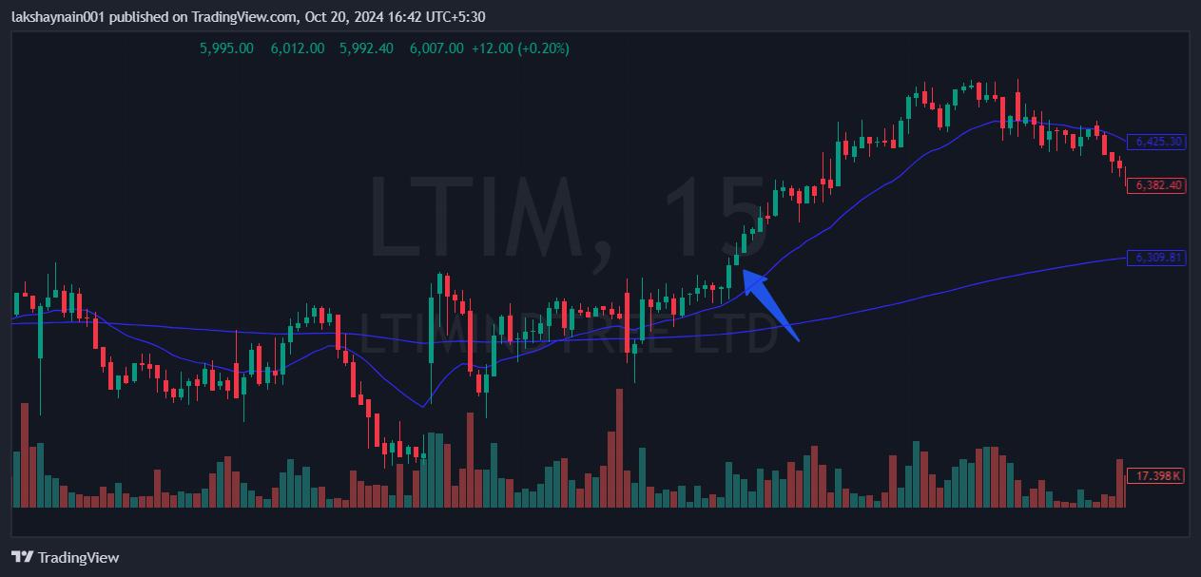
- Price breaks week’s high
- Got support from 20EMA

