ICICIPRU 750PE
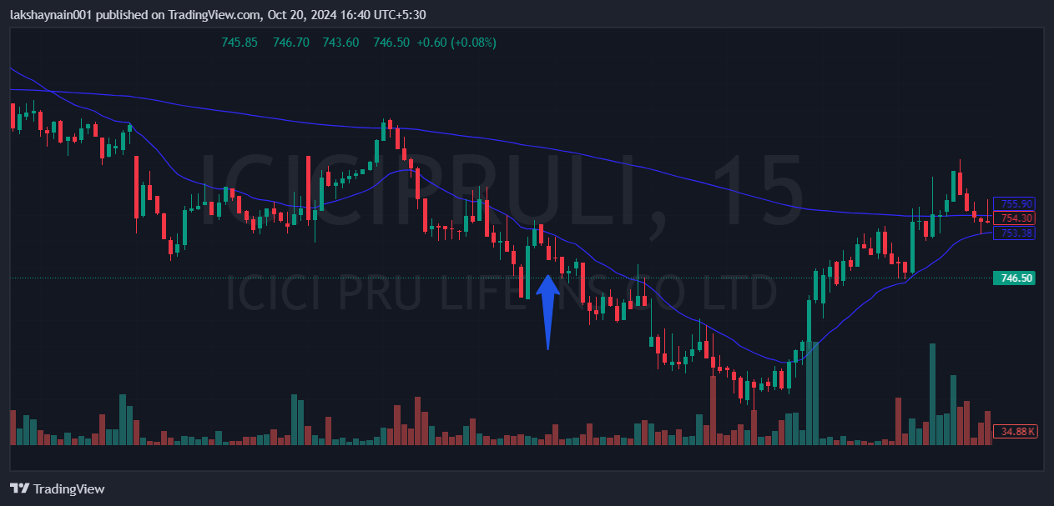
- Price rejected from 20EMA multiple times
- All insurance stocks down
- Trading below 200EMA

