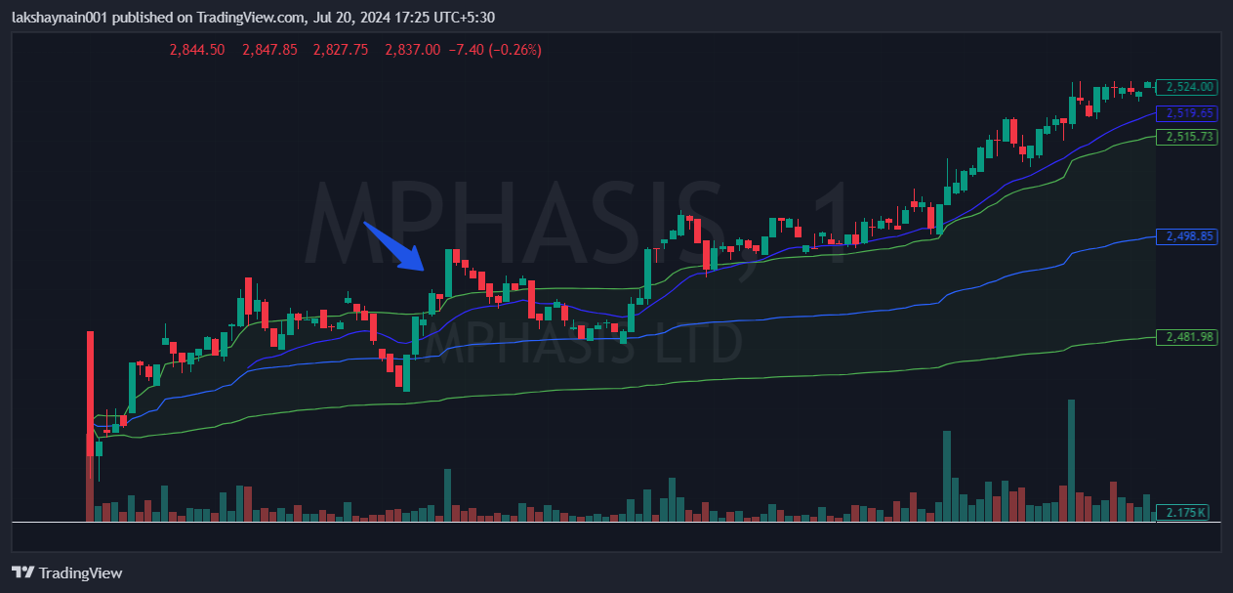
Mphasis 2500CE
- Price break day’s high
- Volume day’s high
- Price above vwap

