SBIN 800CE
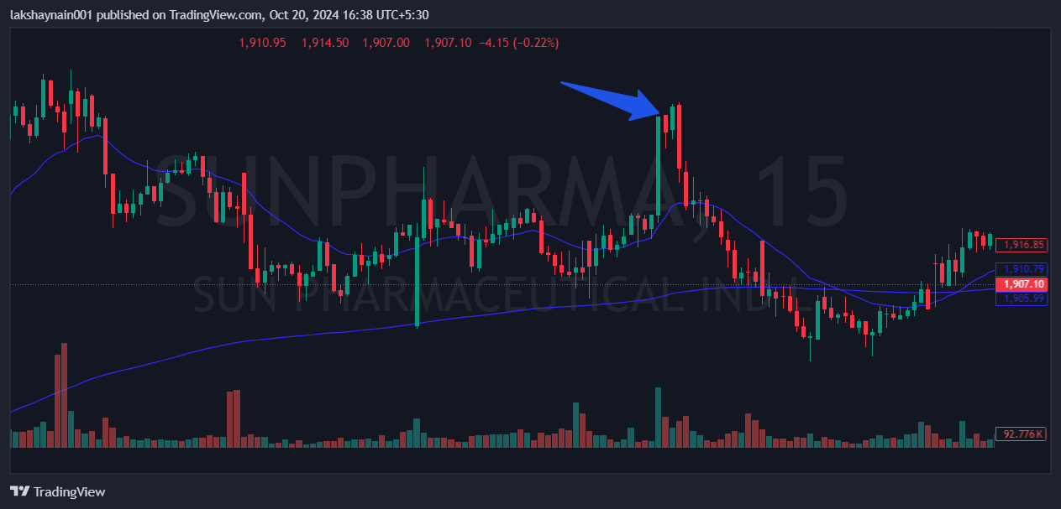
- Price breaks week’s high
- Got thrust from 20EMA
- SL hit below 200HEMA

