Bankbaroda 250CE
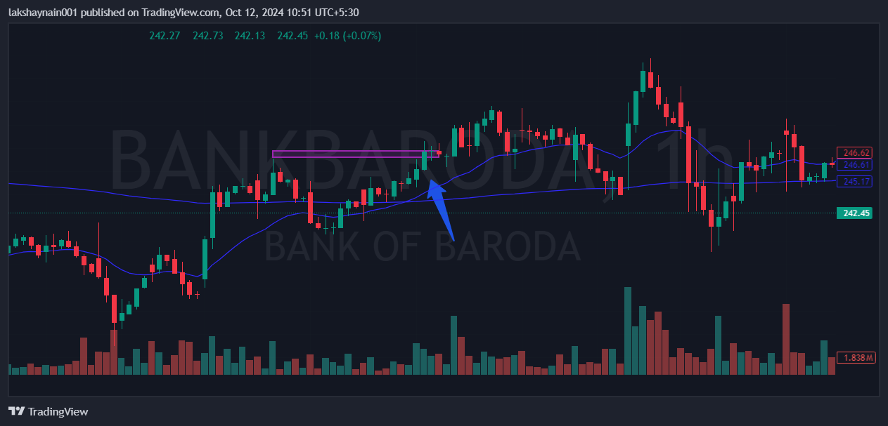
- Price breaks week’s high
- Golden cross over in hourly Tf
- Trading above 20 and 200EMA’s

