HErozero TVSmotor 2900CE
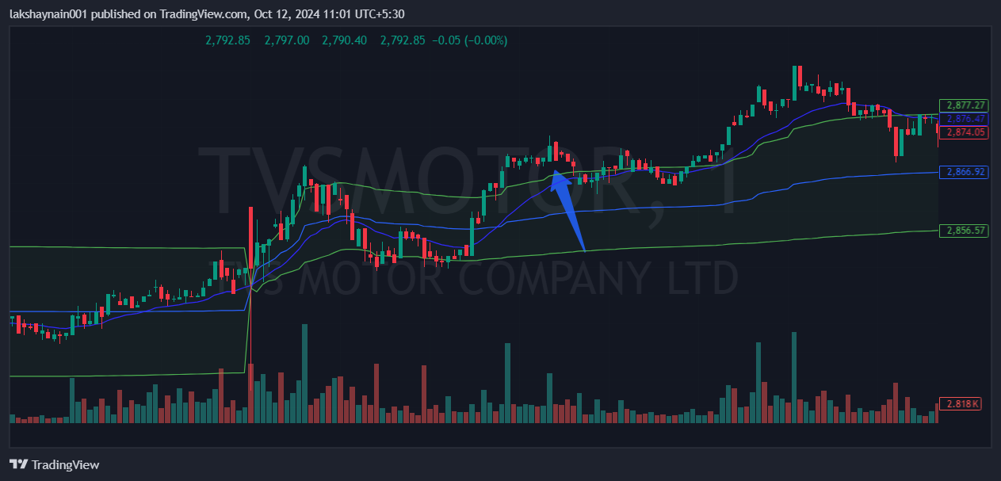
- Price breaks day high
- Crossover of 20EMA and vwap
- Trading above vwap

