ABB 7900CE
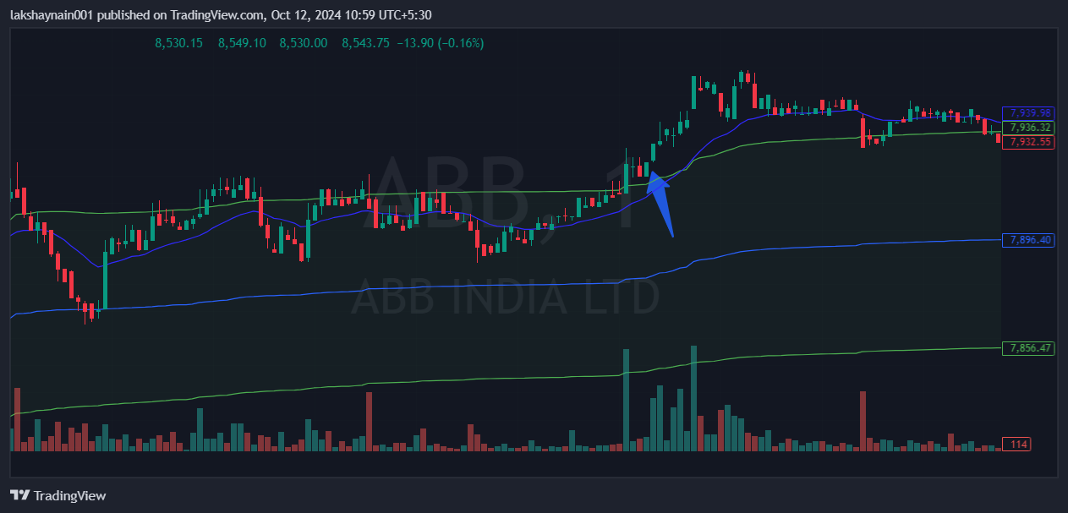
- Breaks day high
- Trading above 20EMA
- Trading above vwap

