CUMMINSIND 3750 CE
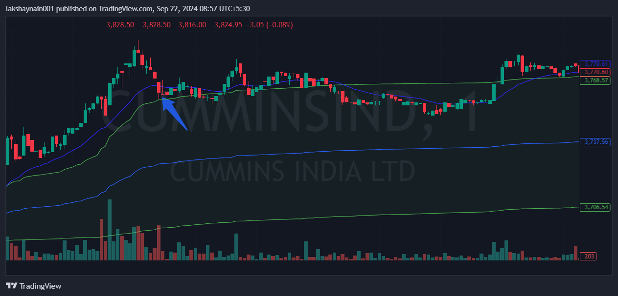
- Price took support at vwap upper band
- Trading on 20EMA
- Trading above vwap

