ESCORTS 4000CE
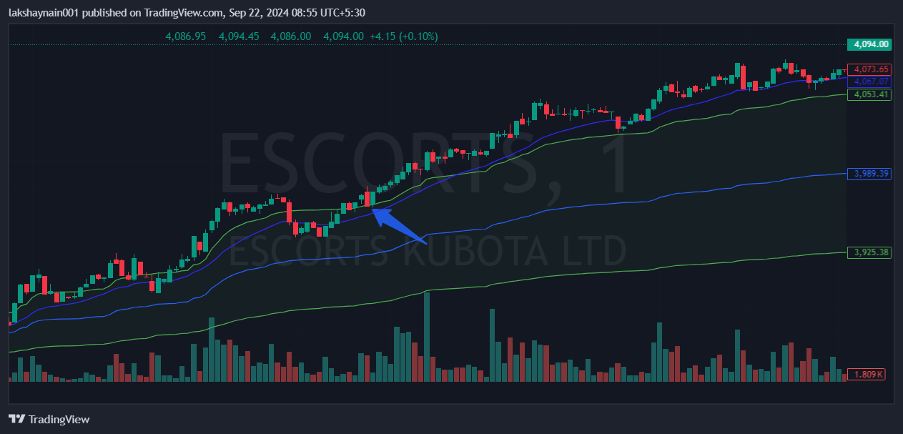
- Nifty auto on move
- Breaks day high above 20EMA
- Trading above vwap

