BHARTIARTL 1640 CE
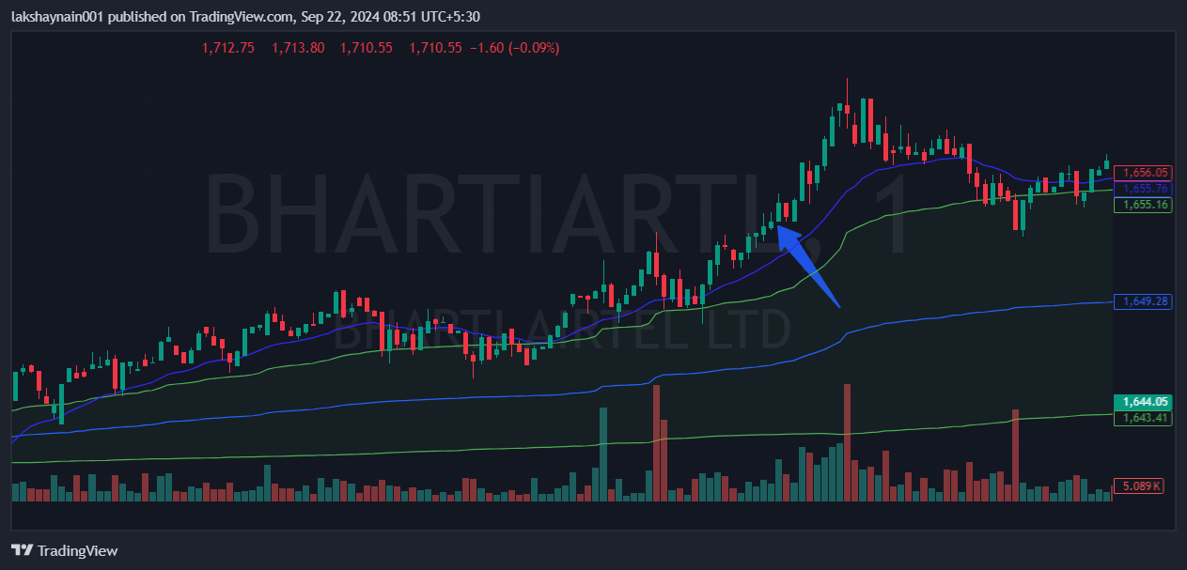
- Price above 20EMA
- Breaks day high with good volumes
- Trading above vwap

