CIPLA 1660 CE
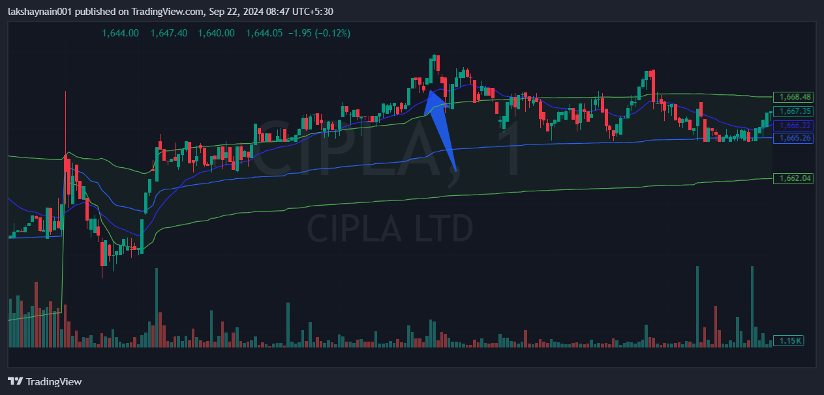
- Price opened gap up in morning
- Brke day high above vwap
SL hit below vwap

