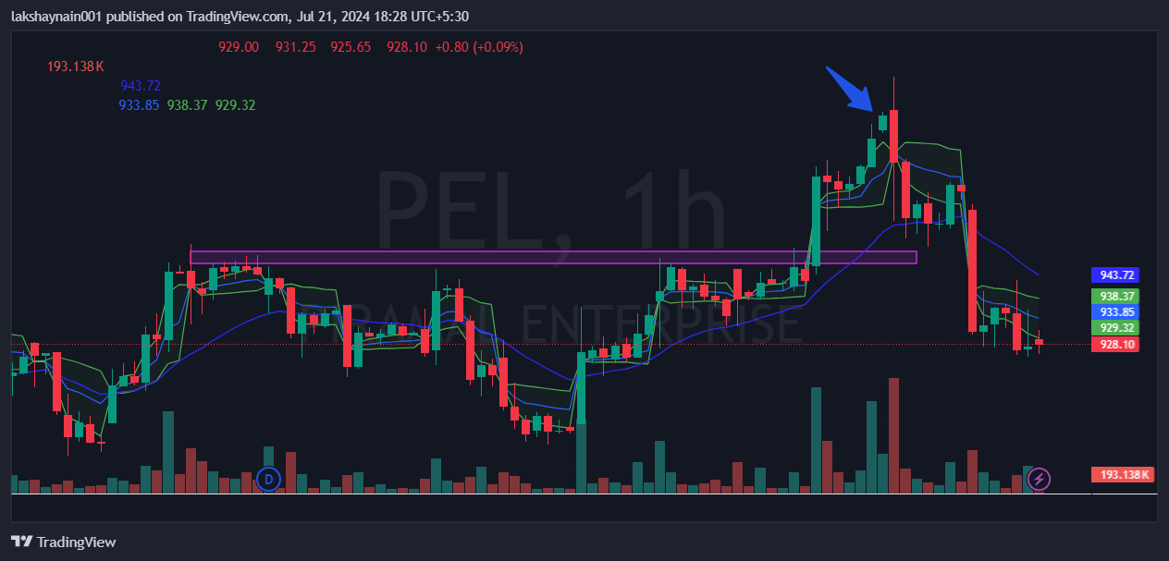
PEL 1000CE
- Price broke previous hourly RTz with strong volumes
- Price at all time high
- Price was above vwap and 20EMA

