HAVELLS 1960 CE
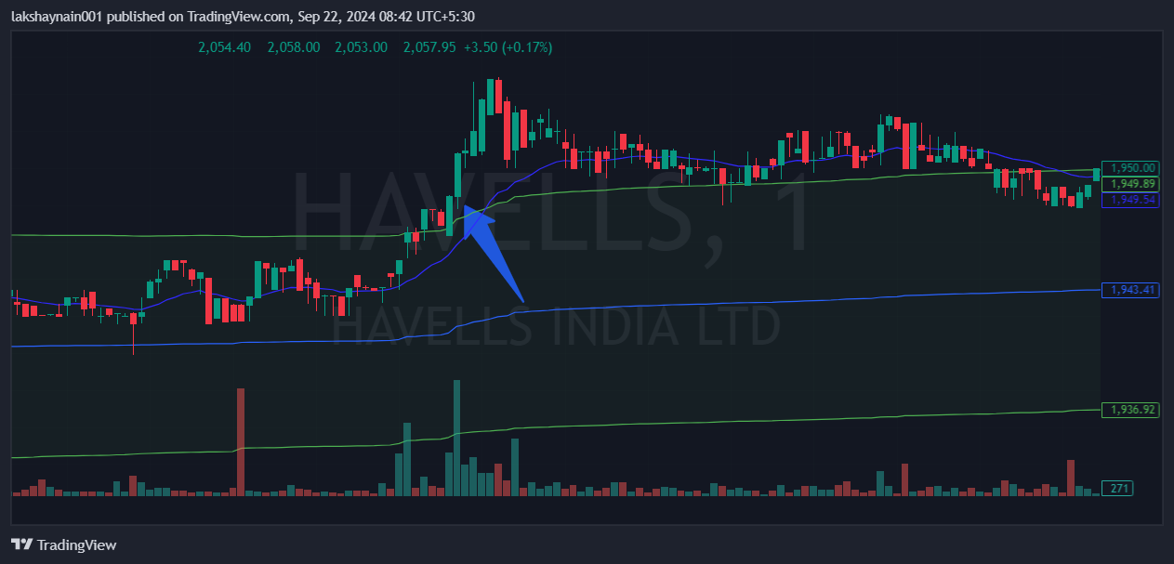
- Price broke day high with volumes
- Trading above 20EMA
- Trading above vwap

