PERSISTENT 5400 CE

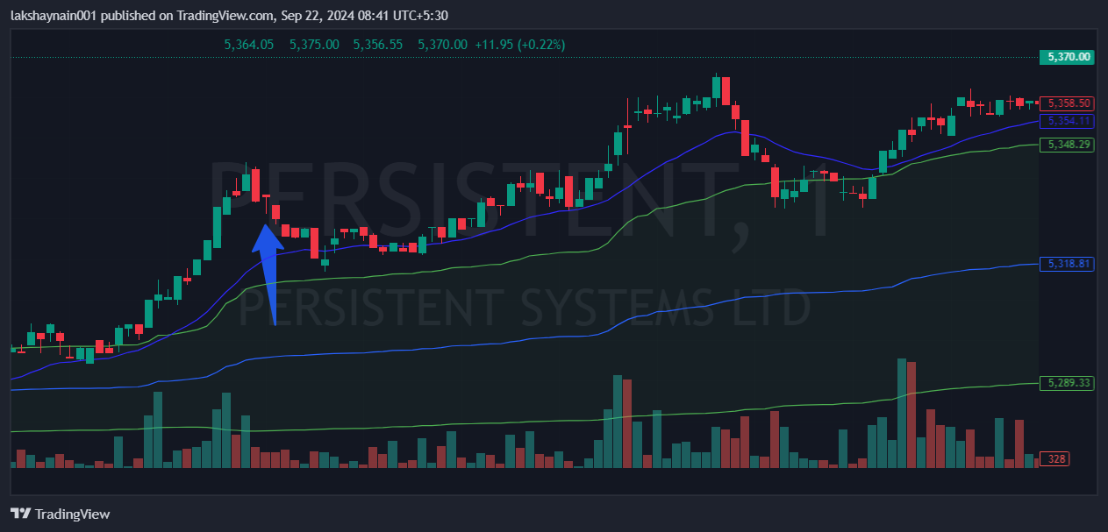
- Price at day high
- Strong 20EMA support
- Trading above vwap

