POLYCAB 6700 CE
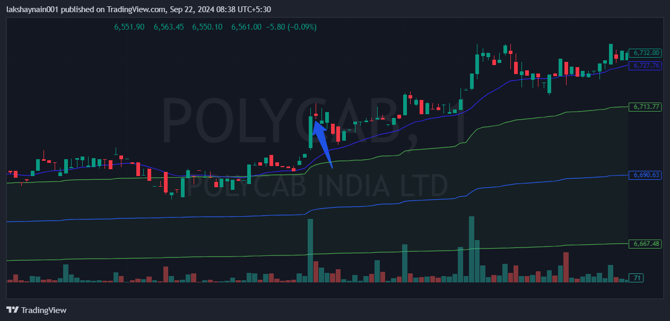
- Price at day high
- Trading above vwap and 20EMA

