TITAN 3700 CE
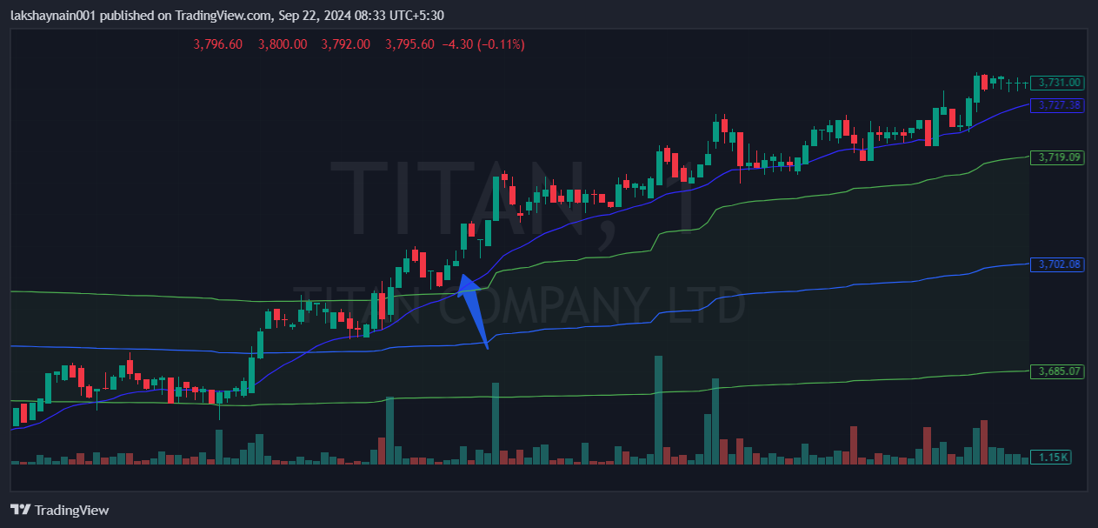
- Price trading above day high
- Strong vwap support
- Trading above vwap

