NAUKRI 7500CE
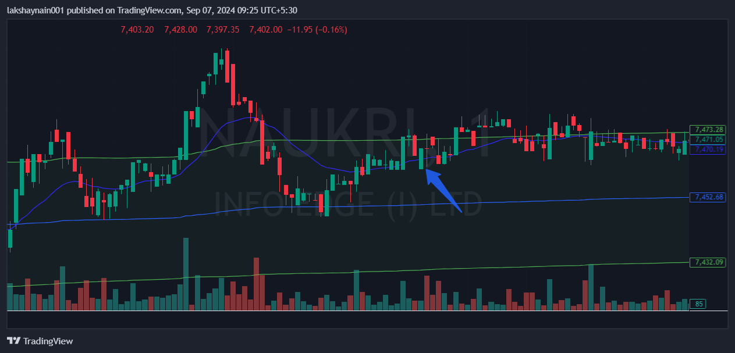
- Price bounced from vwap
- Trading above 20EMA
- SL hit for risky below vwap

