ULTRACEMCO 11500 CE
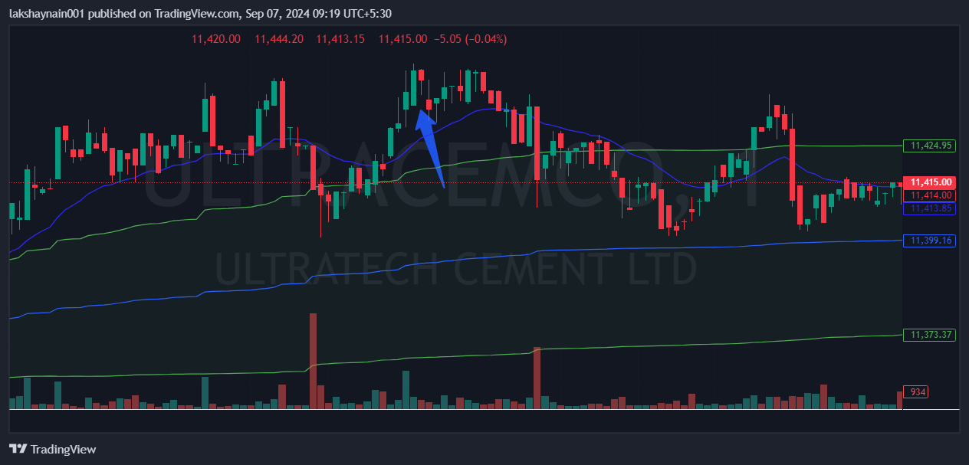
- Breaks day high with good volumes
- Trading above vwap and 20EMA
SL hit below vwap

