ADANIENT 3050 CE
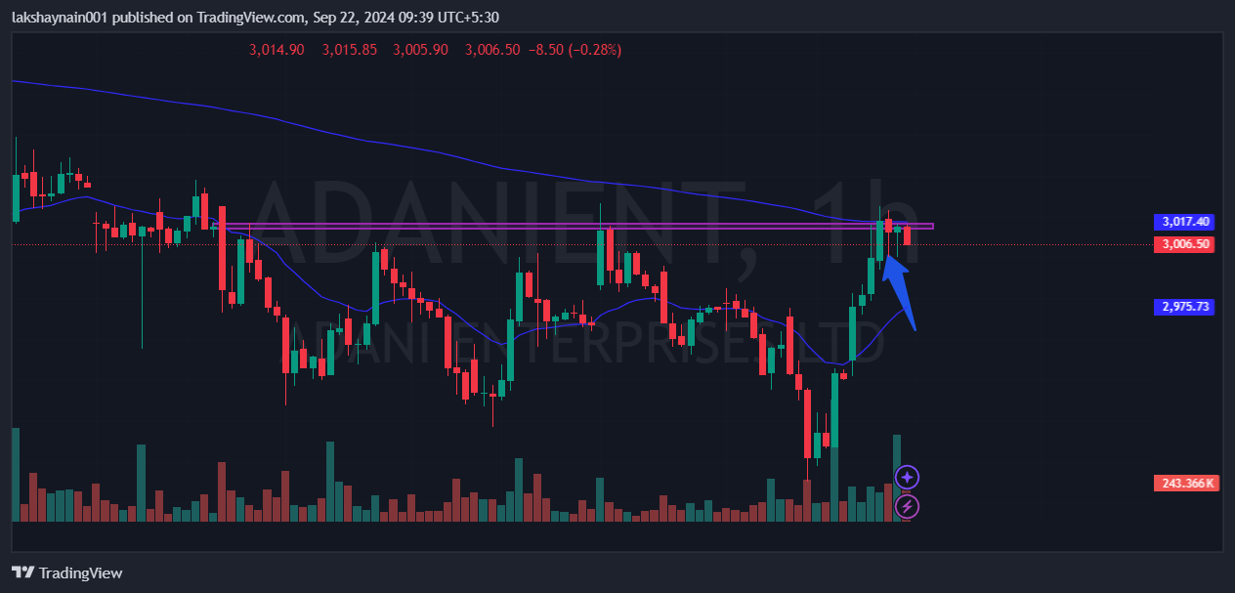
- Price got bounced from 200HEMA
- Trying breaking resistance at 20HEMA
- Volume profile on buy side

