HINDPETRO 410 CE
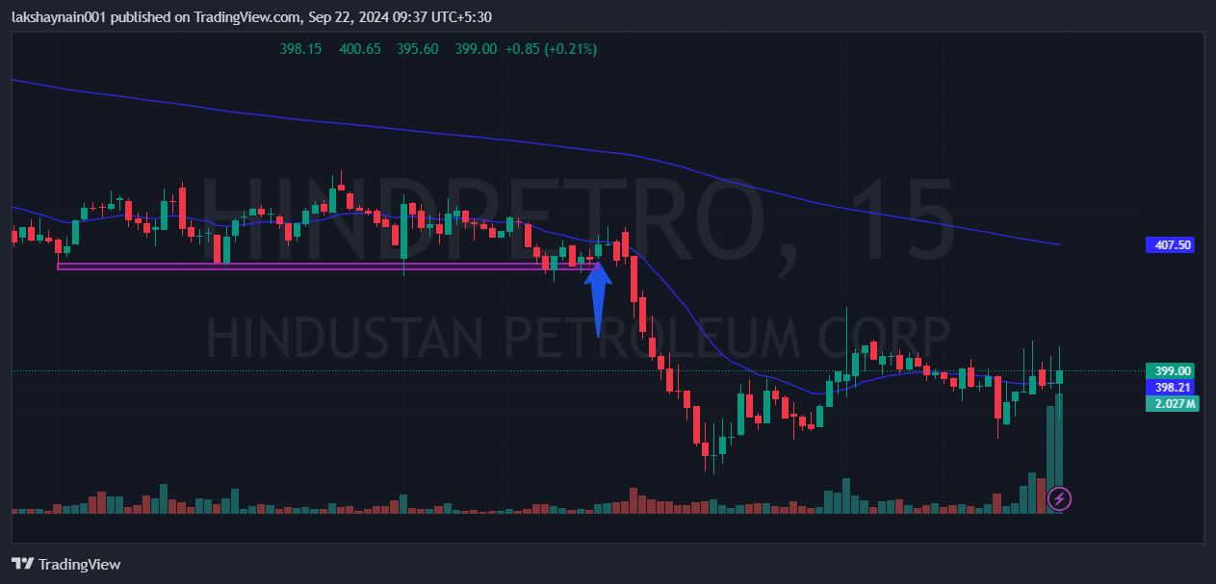
- Price was at support
- Got reaction from support
- SL hit below support zone

