POWERGRID 340 CE
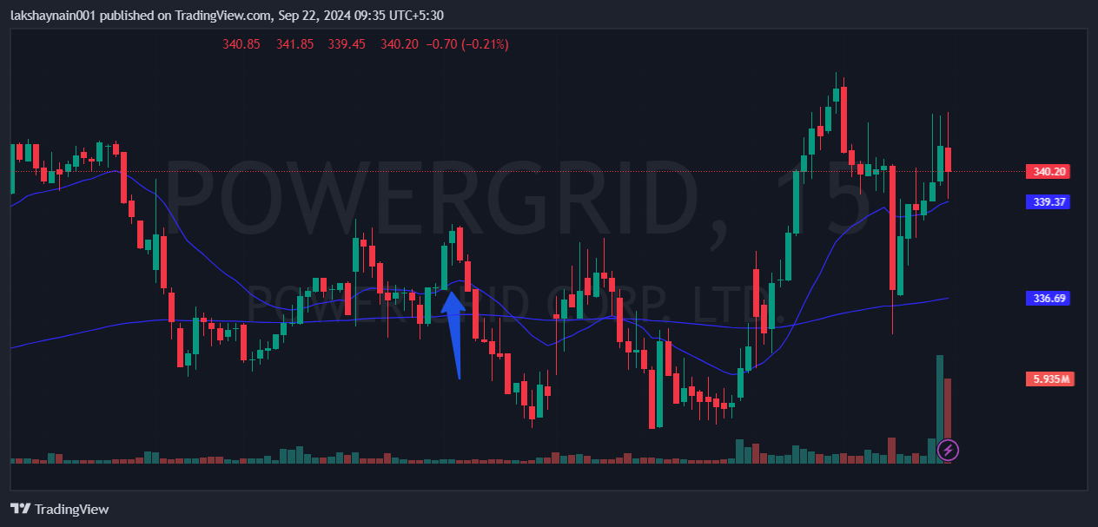
- Price bounced from 200EMA
- Trading above 20EMA
- SL hit below 20EMA

