Atul 8000CE
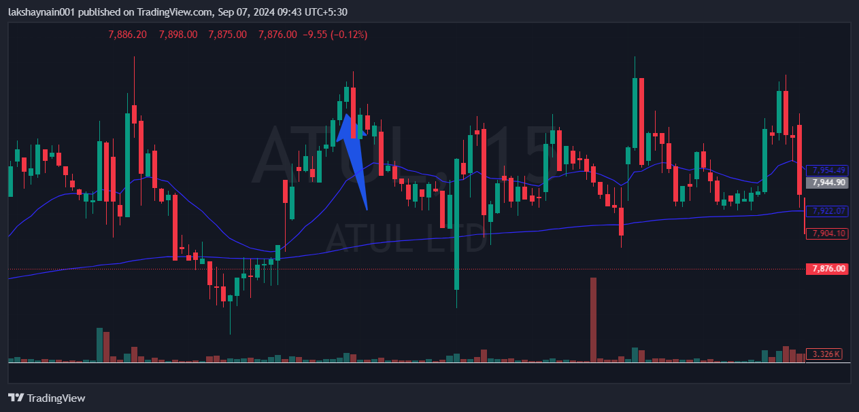
- Price opened gap with resisting death crossover previous day
- Breaks day high
- SL hit below 200EMA

